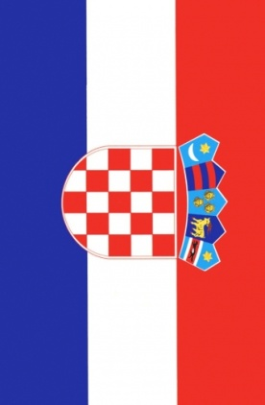
Gregor Čavlović, 13
Elementary school “Bukovac“, Zagreb, Croatia
Klepetan and Malena

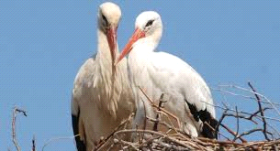This is not a usual love story; it’s a story about birds. It all started approx. 12 years ago in one small village in Croatia called Čigoć. One female stork named Malena ("The Little") with a broken wing has been visited by a male stork Klepetan („Windbag") in her nest on the top of a house, they immediately fell in love. As all of you know, storks fly south to Africa because of the cold winter temperatures. Sadly this was not the case with 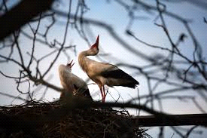
Malena because of her broken wing.
Klepetan returns every spring, around 24th of March.
We are still expecting his return in March of 2015.
Every year Malena hatches eggs with the new family members inside, she has hatched more than 46 baby storks that leave the nest in autumn like their dad.

