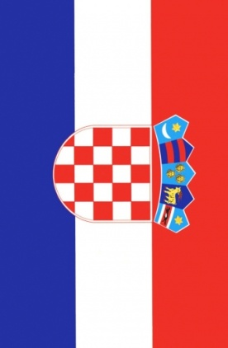
Ivan Skorić, 13
Elementary school “Bukovac“, Zagreb,
Croatia

Kolinda Grabar-Kitarović and Jakov Kitarović
Kolinda Grabar Kitarović and Jakov Kitarović are married and have two children: Katarina and Luka. They got married in 1996. They live in Bruxelles but they plan to move to Croatia. Kolinda Grabar Kitarović is a Croatian diplomat and politian. She is the Assistant Secretary General at NATO. She was the Minister of Foreign Affairs of Croatia and Croatia's Ambassador in the United States.
In 2015 she became the first Croatian female president.
Except Croatian, she speaks English, Portuguese and Spanish. Her husband, Mr. Jakov Kitarović was a professor on Maritime University in Rijeka. He helped his wife during the presidential campaign. He is very supportive. They were in visit to the American president Barack Obama and his wife.
