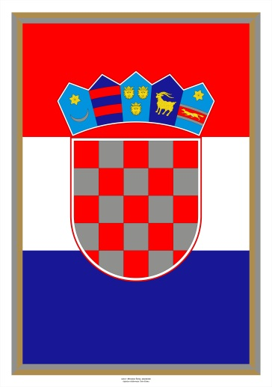
Ruben Luca Lacko,13

Leonarda Stanarević,12

Elementary School Bukovac,Zagreb,Croatia

Ana Katarina Zrinski and Petar Zrinski
a Croatian historical love couple

Katarina and Peta Zrinski were a Croatian couple from the 17th century. Ana Katarina Zrinska was born in the House of Frankopan - Croatian famous noble family. She married Petar Zrinski at the age of 16 and later became known as Katrina Zrinska. Their love was big.
Petar was a victim of a conspiracy and austrian court convicted him and sentenced to death by decapitation. In the last letter to his wife Petar Zrinjski wrote…

peter zrinski’s letter to katarina in Croatian
Moje drago serce.
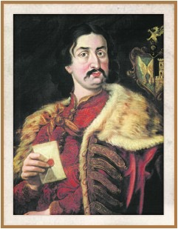
Nimaj se žalostiti zverhu ovoga moga pisma niti burkati. Polag Božjega dokončanja sutra o desete ore budu mene glavu sekli, i tulikaj še naukupe tvojemu Bratcu. Danas smo mi jedan od drugoga serčeno proščenje uzeli. Zato jemljem ja sada po ovom listu i od tebe jedan vekovečni valete, Tebe proseči ako sam te v čem zbantuval ali ti se v čem zameril (koje ja dobro znam) oprosti mi. Budi bog hvaljen, ja sam k smerti dobro pripravan niti se plašim. Ja se ufam v Boga vsamogučega koji me je na ovom svitu ponizil, da se tulikaj še mene hoče miluvati, i ja ga budem molil i prosil (komu sutra dojti ufam se) da se mi naukupa pred njegovem svetem thronušem v dike vekovečne sastanemo. Veče ništar ne znam ti pisati, niti za sina za druga do končanja našega siromaštva. Ja sam vse na Božju volju ostavil. Ti se ništar nej žalosti ar je to tak moralo biti. V Novom Mestu pred zadnjim dnevom mojega zaživljenja, 29 dan aprila meseca o sedme ore podvečer, leta 1671. Naj te Gospodin Bog s moju kčerju Auroru Veroniku blagoslovi.
Groff Zrini Petar

peter zrinski’s letter to katarina in English
My dear soul!
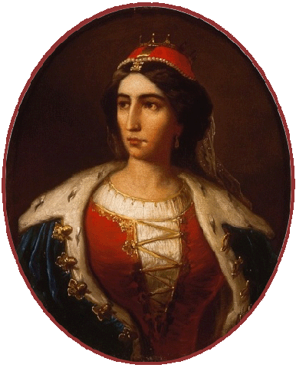
I most humbly beg of you, that you would not grieve yourself to excess, at the sight of this letter.Tomorrow, Ah Madam , I must tell you, Alas! Tomorrow about ten o’clock in the morning, wombats lose our Heads. I and your brother.Today we have taken our last farewell; and now I come also to take leave of you , my dear Soul; forever entreating you that you will please pardon me all things, whereby in all my life time, if I ever offended you. God, who had created me, will have pitty on me, whom I will also beseech, for I hope I shall tomorrow be in this presence, that woman see each other eternal glory before his Throne. As to anything else, I can write nothing, neither concerning my Son, nor any disposal of what I have in the World, having resigned all to the will of God. Afflict not yourself beyond measure, for God will have it so. Neuestadt, the last day of my life: Being the 29th of April , at 7 o’clock at night, in the year 1671. God preserve you and bless you, and my Daughter Aurora Veronica Amen.

