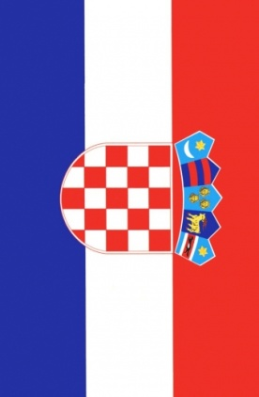
Matea Bajs (12) and Vesna Živko (13)
Elementary school “Bukovac“, Zagreb, Croatia

VEDRAN ĆORLUKA AND FRANKA BATELIĆ

Franka Batelić is 23-year-old Croatian pop-rock singer born on 7th June 1992 in Rijeka, Croatia. Her career started when she won Croatian Showtime music competition in 2007. She lives in Zagreb, Croatia
Vedran Ćorluka is 28-year-old footballer. He was born on 5th February 1986 in Derventa, Croatia. He started to play footbal in age of 8. He currently plays for Lokomotiv Moskva, and he lives in Moscow.
We don't know exact how relationship started. We just know ti became public after they had been seen together on Motovun film festival in the summer of 2012. Even though they are miles away, he lives in Moscow and she lives in Zagreb,their relationship lasts more than two years. They had been on many travels all the world together, and perhaps the most recent one is this Christmas holidays trip to New York. It's not confirmed yet, but there are some rummors about couple planning on wedding. It is very likely that rummors are indeed true since their love is all over the social networks and their feeling are very clear since we have this Vedran's statement: “I liked everithing about Franka, since the first time I met her. I don't know did I find my soulmate, but I know I found something I would wish every man to find.“
Even though their relationship was labeld as “not long termed“ hire they are, after two years looking happy as the first day. We hope this love will last as long as possible, and we are very excitingobout this love birds possible wedding.

